
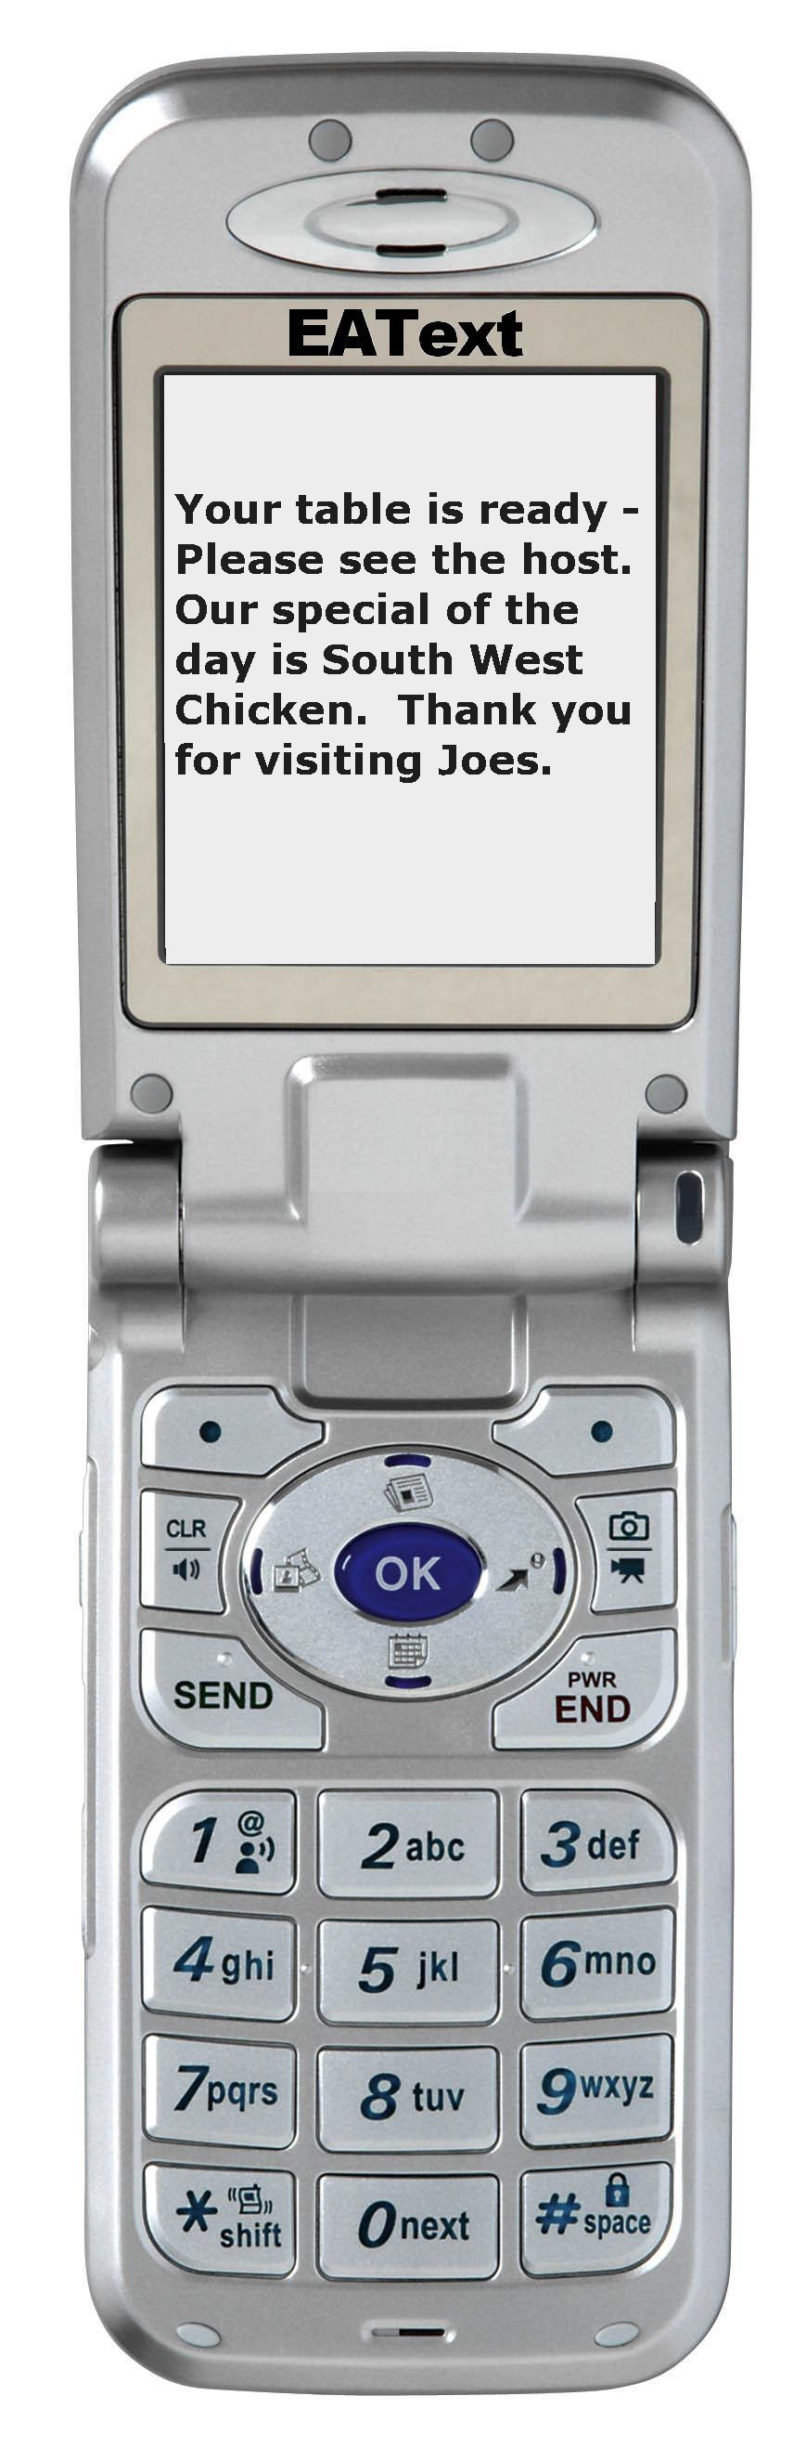
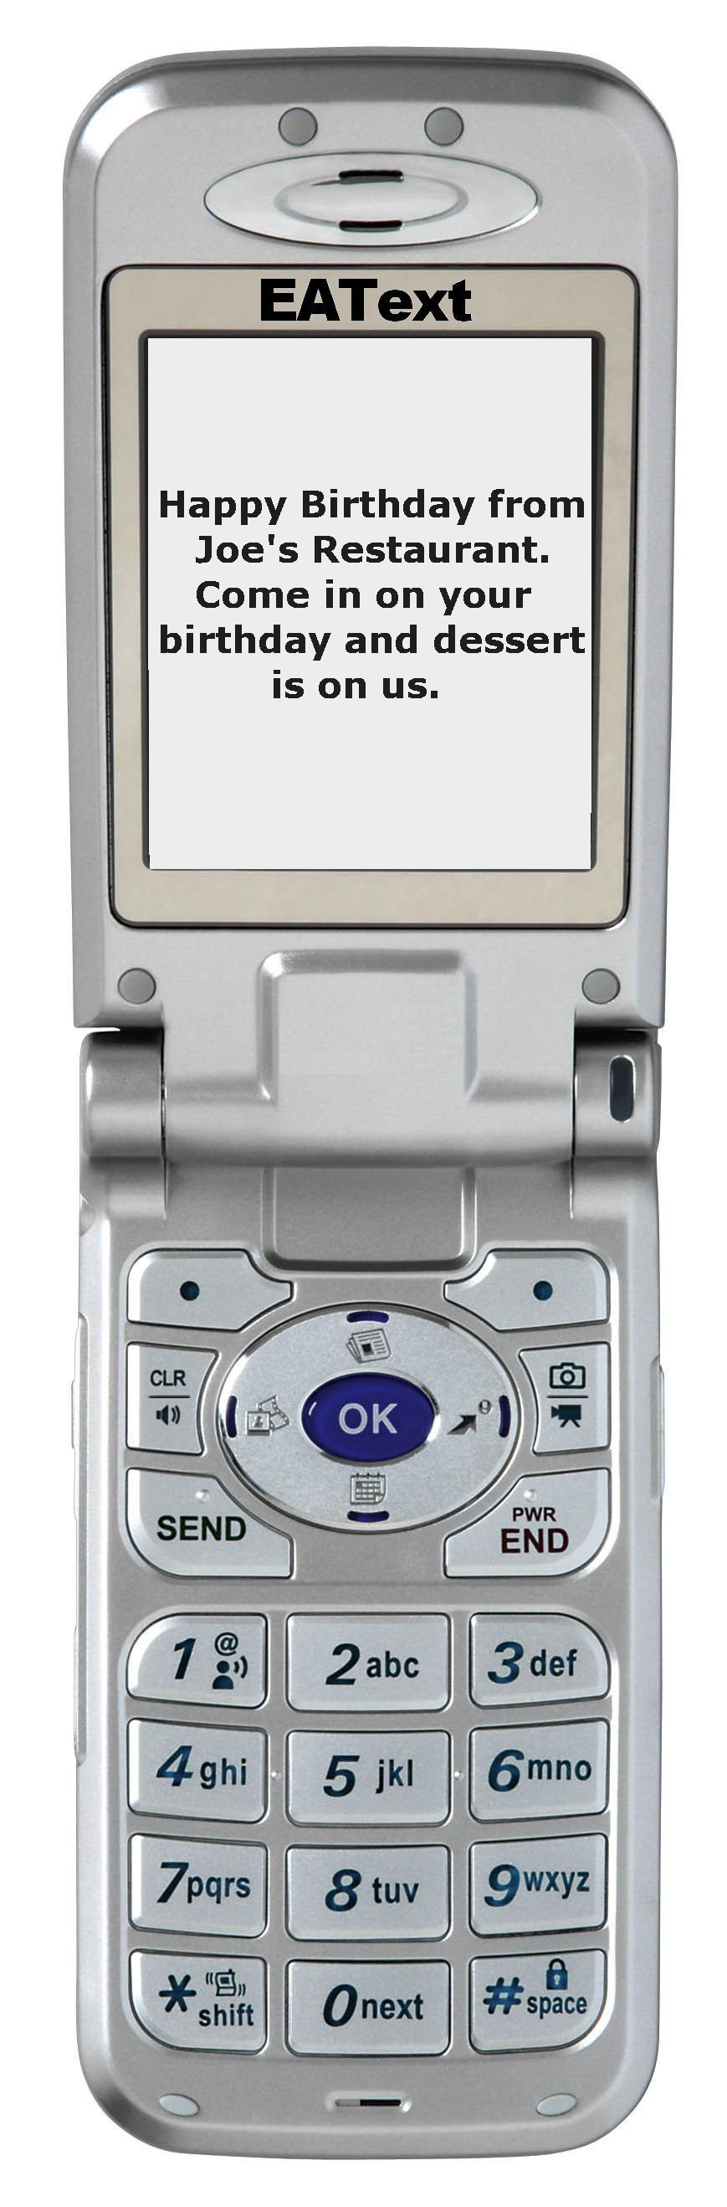

Text Messaging for your Restaurant

EAText is the perfect tool to increase profits in your restaurant

Guest Paging – Manage your reservations and send a customized text message to your guests when their table is ready.

Opt-In Advertising - Keep your loyal customers coming back with targeted text message promotions, and birthday offers.

Customer Trend Reporting – Know everything about your guest volumes, wait times, cancellations, and more.
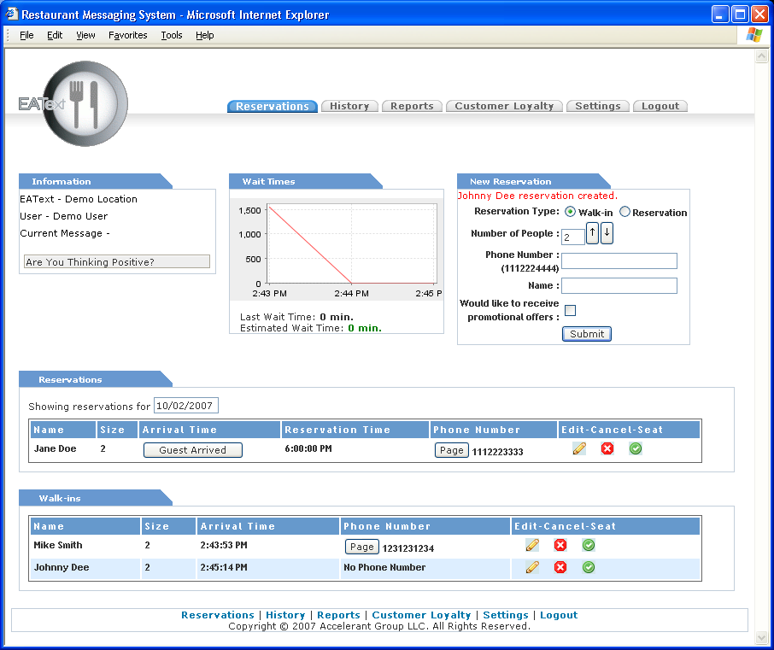

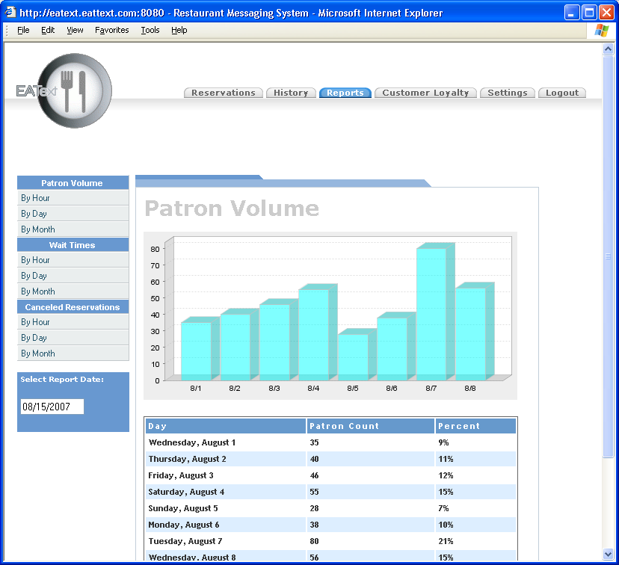
Benefits to Restaurant
- Target guests with promotions
- Eliminate costly paging equipment
- Minimize staffing costs
- Detailed Reporting
- Higher levels of customer care
Benefits to Guests
- No need to carry a pager
- No need to stay within range of the paging system
- Receive targeted promotions, including birthday specials

For More Information
Visit - www.accelerantgroup.com
Email - info@accelerantgroup.com
Call - 800.788.9487

