
What is EAText?

EAText is a reservation management and messaging system.

Guest Paging – Manage your reservations and send a customized text message to your guests when their table is ready.

Opt-In Advertising - Keep your loyal customers coming back with targeted text message promotions.

Customer Trend Reporting – Know everything about your guest volumes, wait times, cancellations, and more.

Benefits to Guests

- No need to carry a pager
- No need to stay within range of the paging system
- Receive discounts, offers, and promotional information

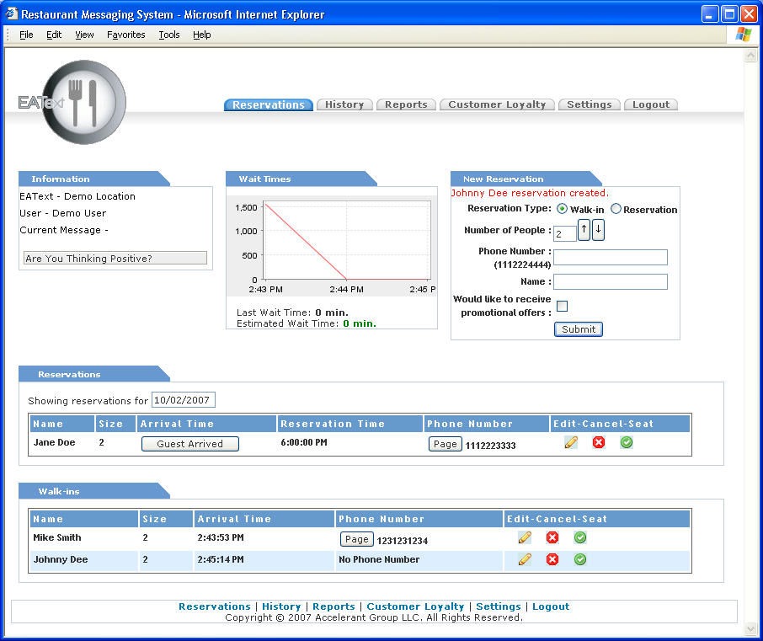

Benefits to Restaurant Manager/Owner

- Target guests with promotions
- Eliminate costly paging equipment
- Minimize staffing costs
- Detailed Reporting
- Higher levels of customer care

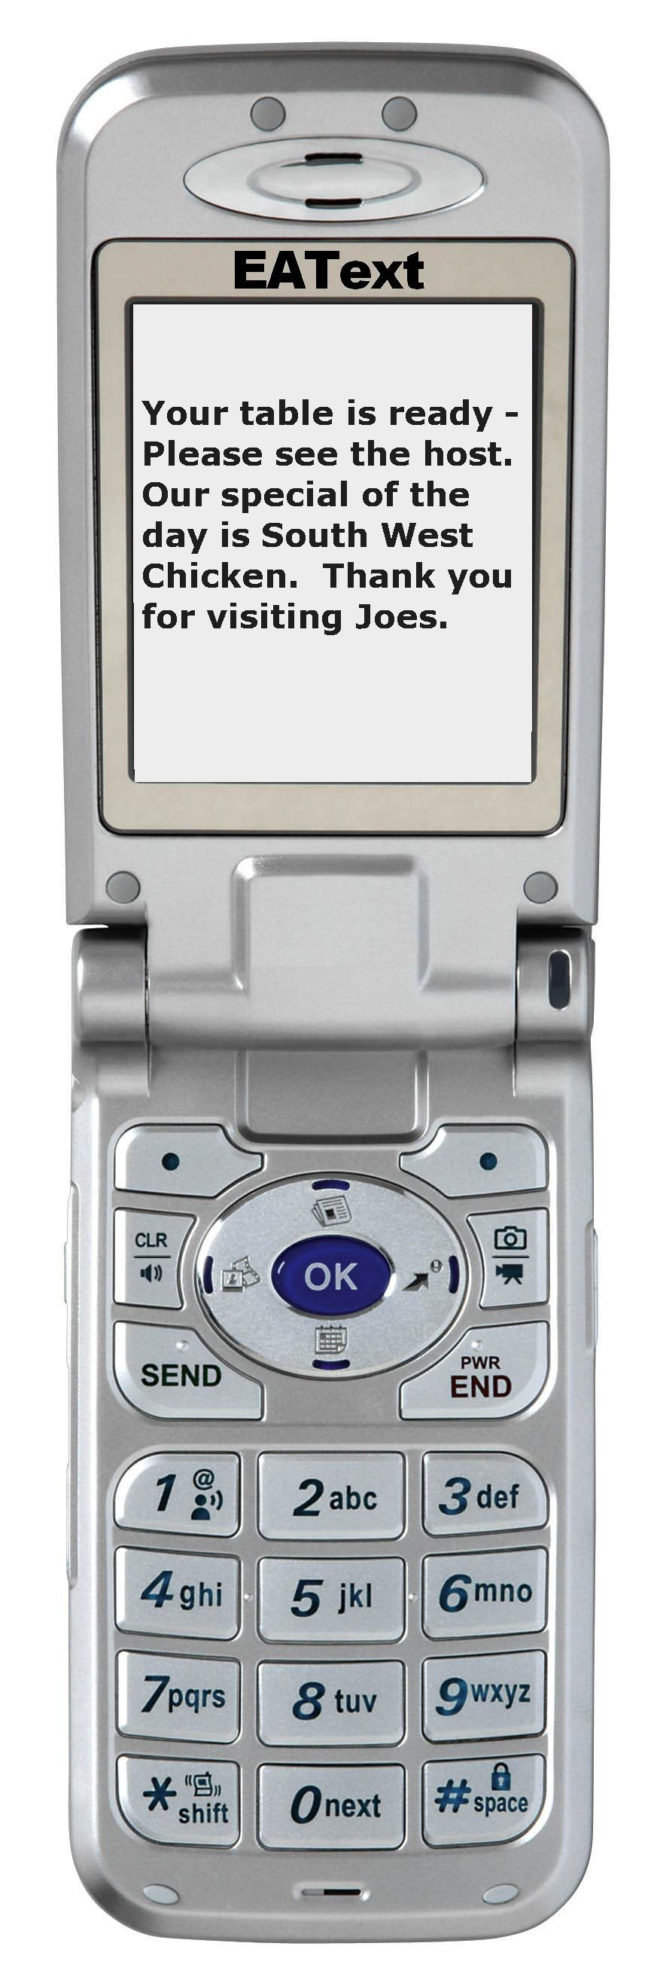
For More Information

Visit

www.accelerantgroup.com

Email

info@accelerantgroup.com

Call

800.788.9487
801.938.7111
The latest advance in Restaurant Messaging
Presenting

